**Lab Assignment-5**

## Team 6-2:

Rohith Kumar Nagulapati, 16

Nageswar Rao Nandigam, 17

### Convolutional Neural Network

Dataset: We used MNIST dataset to build CNN model which is one dataset used for our project evaluation

## Output:

### Accuracy using Adam optimizer

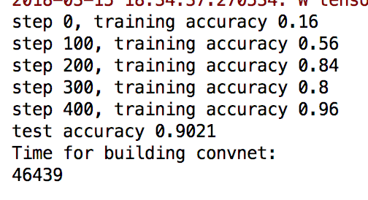

Histogram

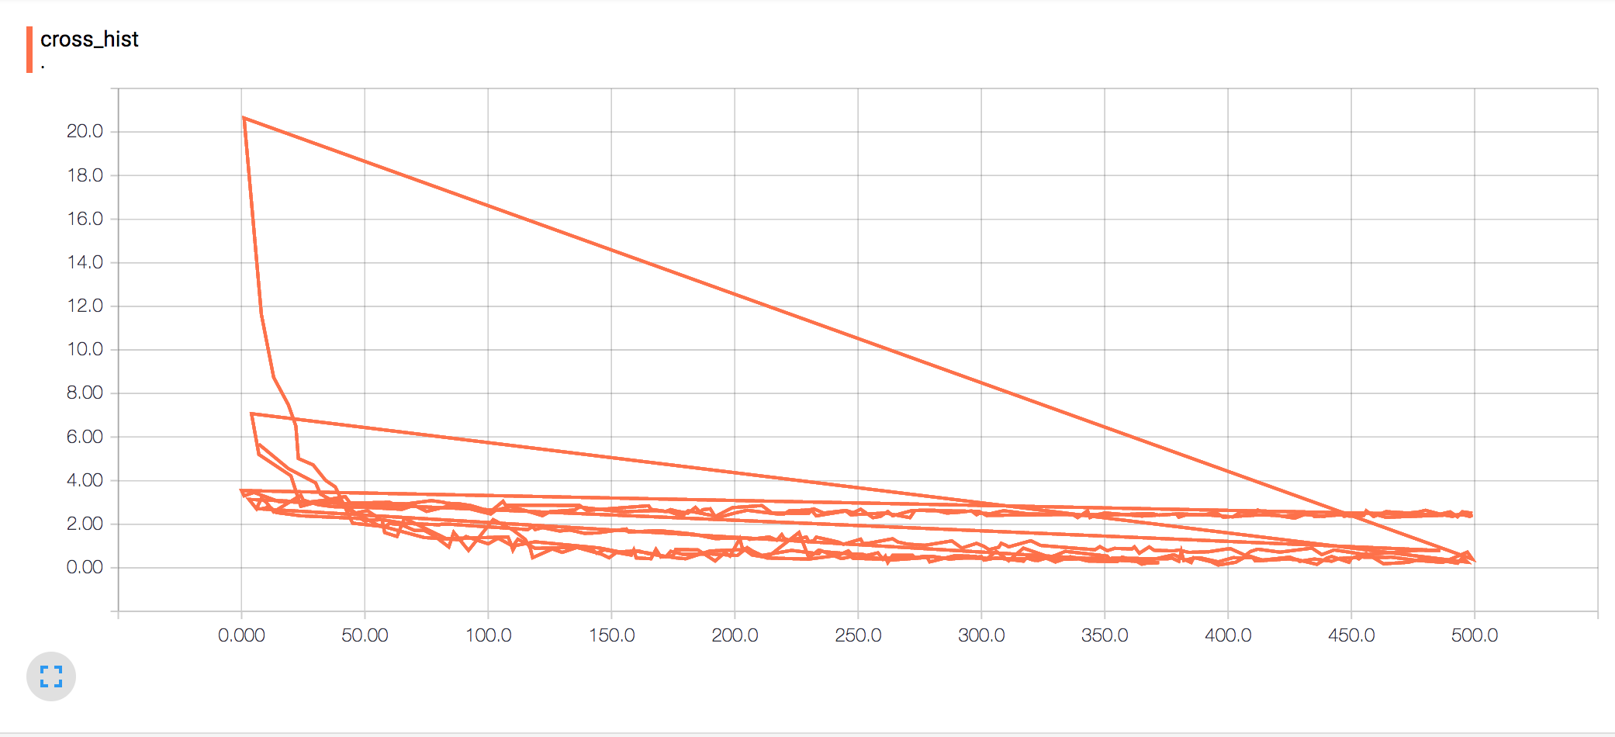

2. Inception model

Dataset: we used a 10-class dataset that has bonsai, airplane etc... as categories

train the given dataset (given in source code) for 100 iterations using the inception model and

report accuracy. Provide Tensor Board visualizations for Training, weights, loss etc. and validation.

Training

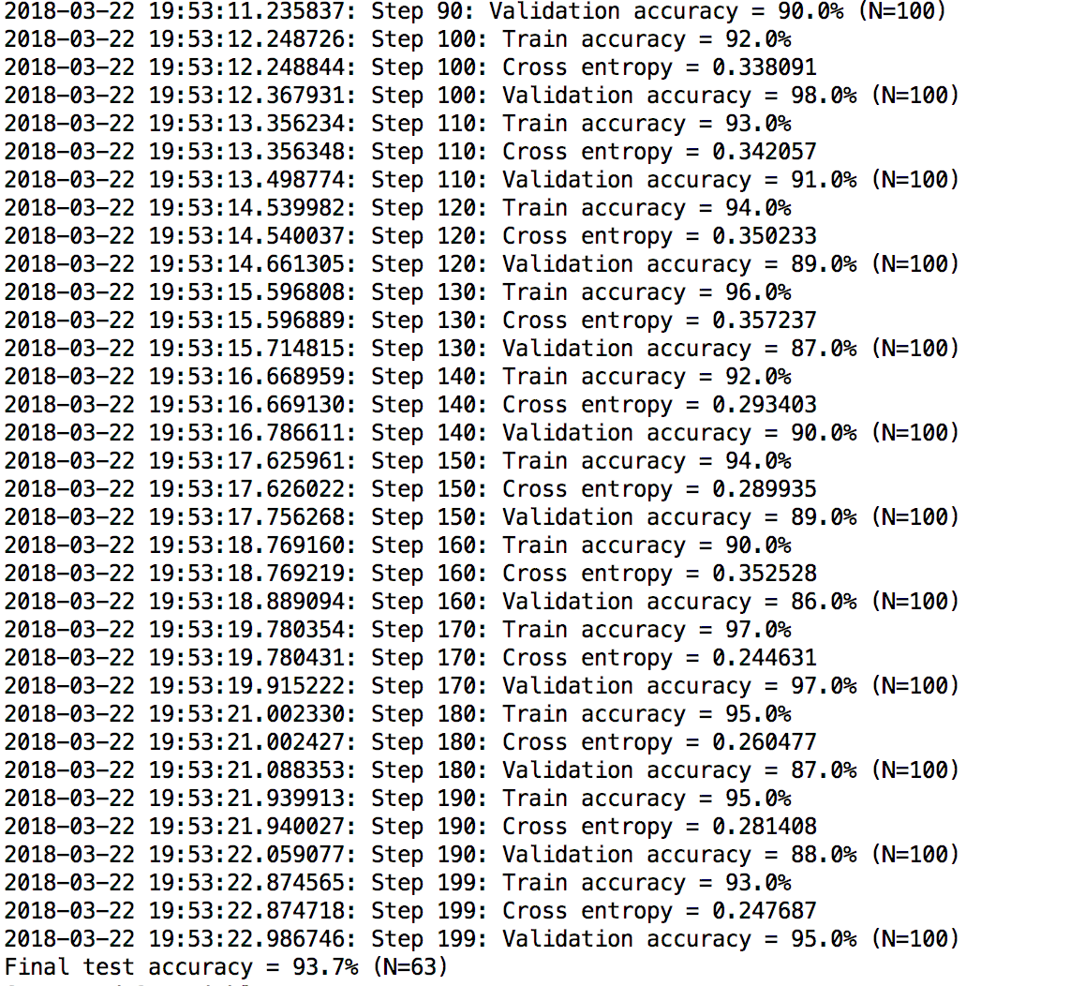

**Accuracy**

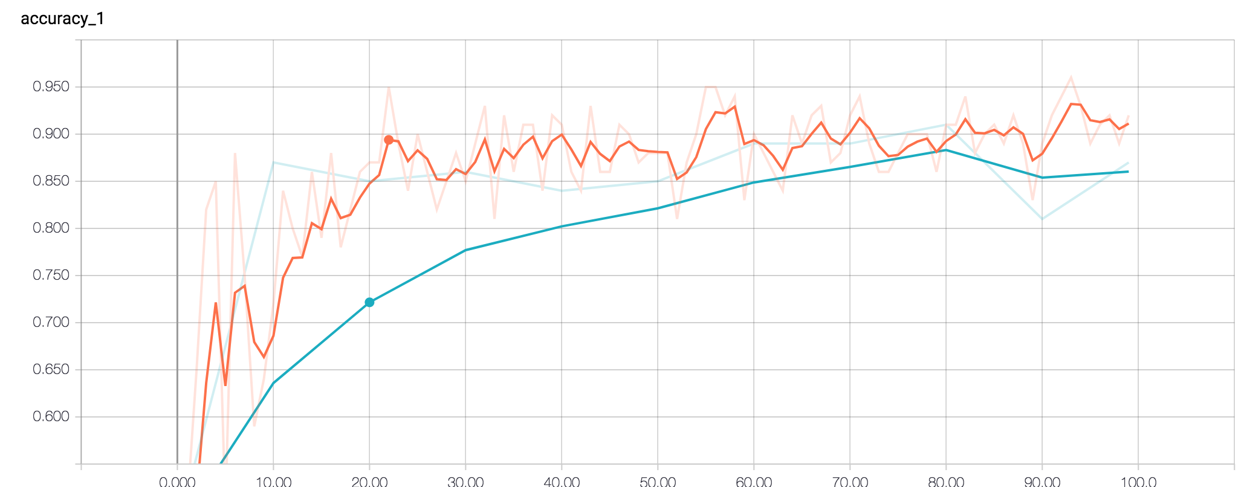

**Summaries**

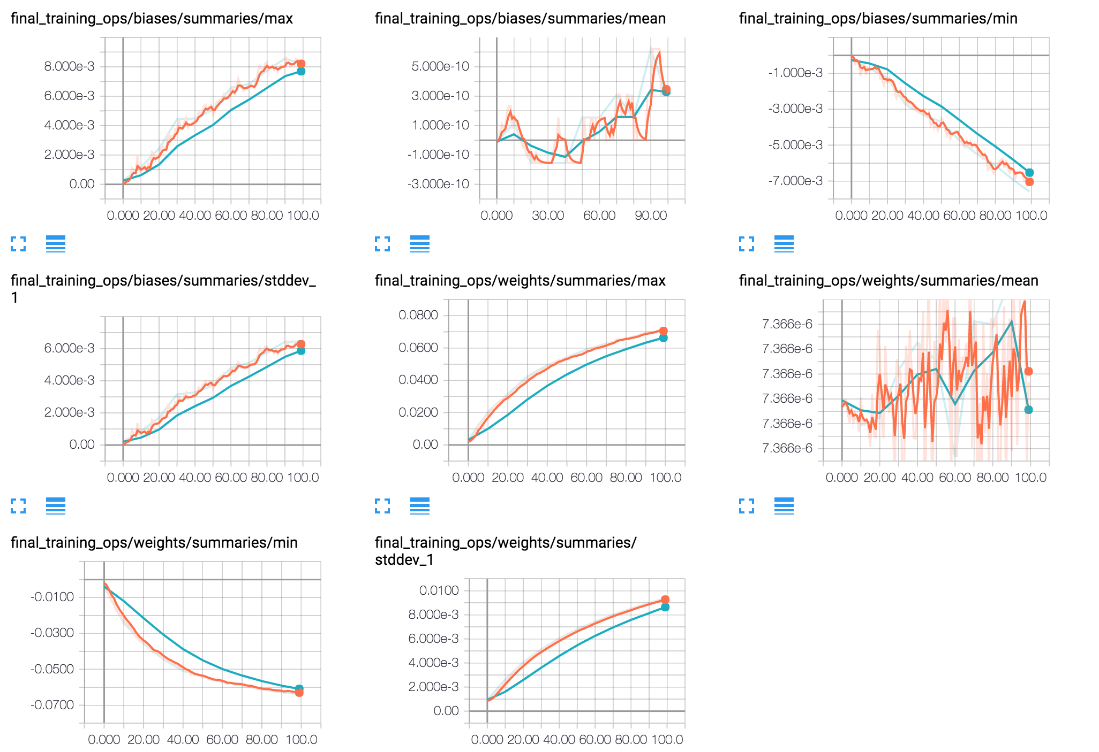

3. CNN-Web for Image Classification

Dataset: We used the above-built model for image classification

Application Screenshot

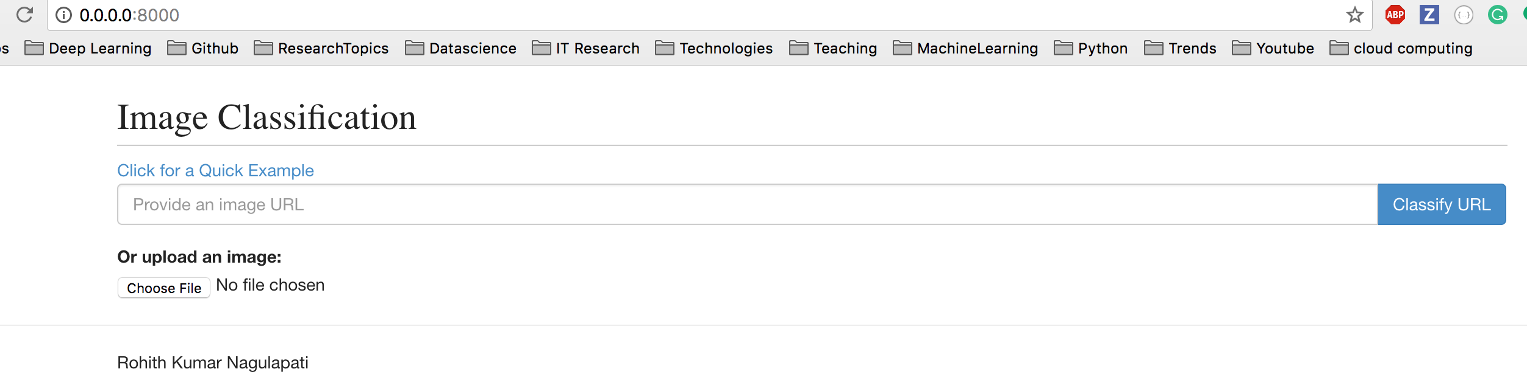

Place to submit the link for image classification



Displaying Prediction Results

